HERITAGE
PINOT NOIR 2013
SOUTHERN VALLEYS • MARLBOROUGH
Auntsfield continues the proud heritage of Marlborough’s first vineyard and winery established in 1873.  Our Single Block wines display qualities distinctive to grapes grown within a defined  area at Auntsfield Estate. Consistent quality and character over many vintages has  separated these Single Blocks out as producing our Reserve Wines.  This wine is only made when a selection of traditionally made wine from our steepest hill side exhibits the intensity, complexity, balance and sense of place required to honour the heritage of Auntsfield Estate: Marlborough’s first vineyard and winery. | 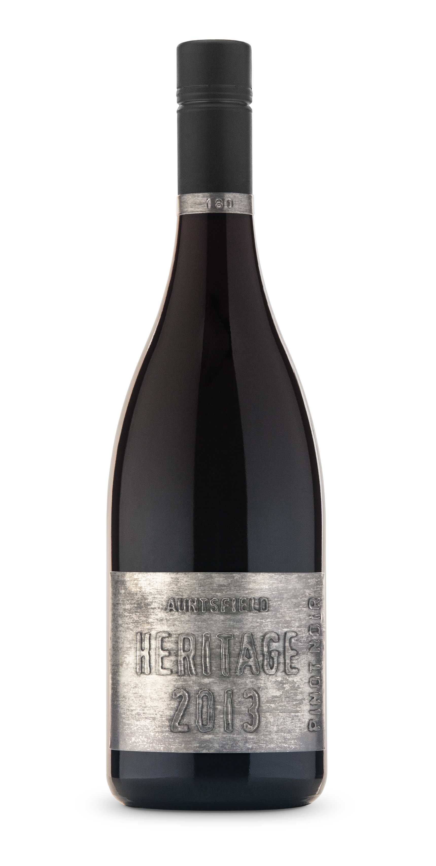
Tasting Notes
COLOUR: Deep ruby, very intense.
AROMA: Savoury and complex aromas of exotic spices, dark berry fruits and floral notes. Hints of cocoa and leather.
PALATE: The palate is immensely dense and concentrated with luscious black fruit flavours integrating with oak spice. The wine has an intense and yet silky fine tannin structure, great length and many years of aging potential.

ANALYSIS: Alc. 14.0% | pH 3.57 | TA 5.5
Winemaker Notes
This wine is made with a sense of place. The steep clay hillsides at Auntsfield give us fruit with great density, complexity and tannin structure. Winemaking is carried out with a desire to reveal these characters in the wine. The fruit is hand harvested and gravity fed into open top oak vessels with a proportion of fruit being whole bunch fermented. These are then hand plunged (with our bare hands) once fermentation begins. The wine is kept on skins for an extended period following fermentation before being aged in oak for 18 months.
Viticulturalist Notes
The 2013 season was characterised by a very an early spring and a very long cool growing season perfect for Pinot Noir. The fruit for this wine comes from the very top of our steepest hillside at Auntsfield Estate. The cropping level is naturally very low (1kg per vine) off these very old slow growing vines that are exposed to the hillside winds and rock hard clay.

