HERITAGE PINOT NOIR 2009
The 2009 vintage is recognised as being one of the great vintage years for Pinot Noir grown in Marlborough.  This wine is only produced in exceptional years when we feel a selection of wine exhibits amazingly defined character. The wine is made in celebration of the Heritage of Auntsfield Estate, Marlborough’s first vineyard and winery.  The very best four barrels of the vintage were hand crafted as a tribute to David Herd who established Marlborough’s first commercial vineyard at Auntsfield in the 1870’s. It also celebrates the 104th anniversary of his final vintage with the addition of a small portion of the only remaining bottle of his 1905 wine. |  | 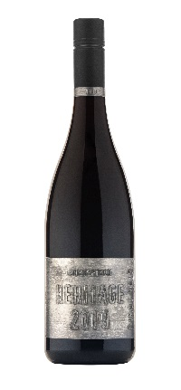
TASTING NOTES  Colour Deep ruby/crimson, very intense | WINEMAKERS NOTES  The Auntsfield Heritage Pinot Noir is only made when we feel that a selection of wine exhibits the intensity, complexity, balance and sense of place required to honour the heritage which David Herd has left us.  This wine is made with a sense of place. The steep clay hillsides at Auntsfield give us fruit with great density, complexity and tannin structure. Wine-making is carried out with a desire to revealing these characters in the wine.  The fruit is hand harvested and gravity fed to open top tanks. The juice is fermented with wild yeast and regularly hand plunged. On completion of fermentation, the wine remains on skins and gently plunged until the appropriate level of tannin extraction is achieved. Due to the intensity of the structure of this wine, it is aged in barrel for a full 18 months before bottling.
Aroma Dark berry fruits of blackberry, plum and cherry notes, and hints of dried spice and floral violet notes. Complex aromas of dark chocolate, dried fig, leather, cigar box and meaty savoury characters.
Palate An intensely weighted wine with great depth and richness from the dense, dark fruit and brooding complexity. The wine is well structured with ripe, fine grained tannins through to the long finish.
Analysis Alc. 14.0% pH 3.61 TA 5.6

